VCS TASK – GIT OPERATIONS

Screenshot 1:
Explanation: Shows the repository is clean with no pending changes.

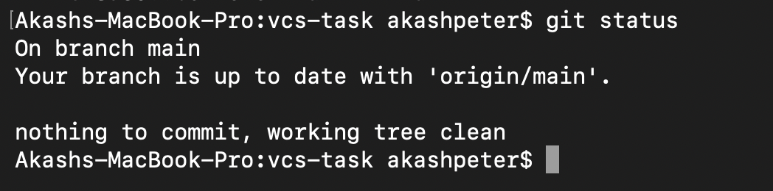

Screenshot 2:
Explanation: Shows multiple branches created and used for merge and rebase operations.

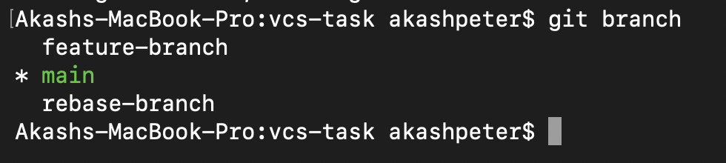

Screenshot 3:
Explanation: Displays commit history proving successful merge and rebase operations.

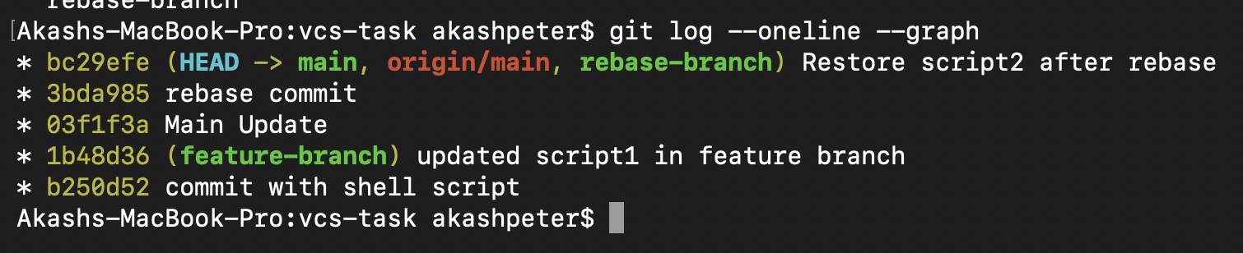

Screenshot 4:
Explanation: Confirms stash was used and successfully restored after rebase.

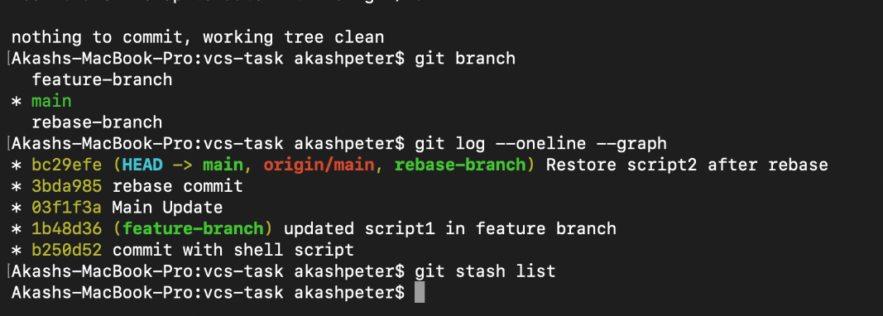

Screenshot 5:
Explanation: Shows all code and commits pushed successfully to GitHub.
